Docker-Compose

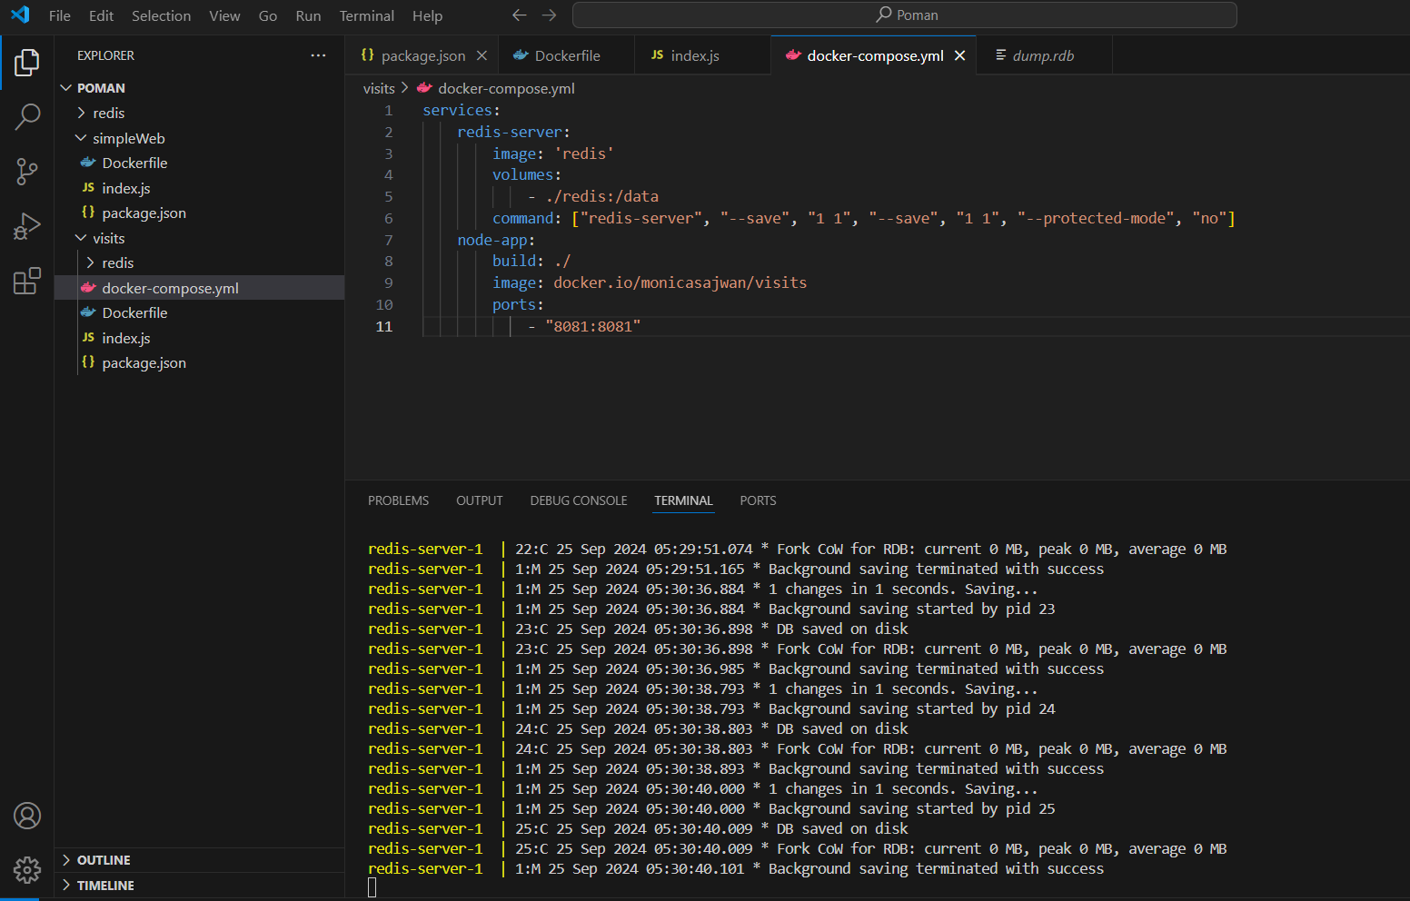

Index.js

Package.json

Dockerfile

Terminal Screenshots:

Localhost:

